AUTUMN AT THE WINERY
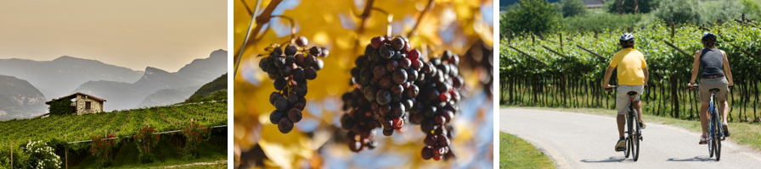
Stories of local wines told by the people who make them, new cycling wine tours, and events dedicated to celebrating the grape harvest, follow the Trentino Food Trail this autumn.

Autumn marks the time for the grape harvest. A time when the vineyards are full of people, and the aroma of wine fills the air around the stunning villages. The winemakers and their extraordinary wines have new stories to tell; stories about working in the vineyards at dawn, about their worries and concerns, about turning their gaze to the sky in the hope of rain from a summer storm. In villages across the region, from Piana Rotaliana to Vallagarina, the locals are preparing for the harvest festivals and to celebrate together with a bottle of wine and other local delicacies. There are many opportunities to enjoy moments like these on the Trentino Wine and Food Trail. There are also plenty of new and exciting opportunities to explore the area, the wineries and the local products via bike.

Wine Tour 50 will immerse you in the Piana Rotaliana for about 50km and includes all six villages in the area, with detours to the north towards Salorno (Alto Adige) and to the east towards Giovo (Valle di Cembra). The route has two rings: one to the north, which is all flat, and one to the south, which has a variety of hills and passes through these hills. The tour leads you through incredibly beautiful vineyards, passing numerous wineries and architectural gems to be discovered one by one. Your tour will also be accompanied by the peaceful flow of the Adige. From small family businesses to wine cooperatives, you can book a guided tour and a tasting at any of the over 50 wineries along the way.

To better appreciate the tour, we recommend going anti-clockwise. The signs will direct you in this route, and in addition to the location of all the local spots, they provide additional information on the nature of the soil and the excellent wines produced in a specific area: Teroldego, Nosiola, Müller Thurgau, Trentodoc. For a less demanding tour, the circular route is preferable and lets you begin at any point. We recommend gravel or trekking bikes or an e-bike for this tour. This route connects directly to the Valle dell'Adige bike path and can also be reached by train. The Trento railway station is a few kilometres away, and the regional trains stop in Mezzocorona as well as Lavis, while all the villages in the area are connected by the local Trento Malè railway on which bikes are permitted by reservation. More information here.

Staying in the Piana Rotaliana area, Wine Experiences are available throughout the year, but in autumn these experiences directly involve the winemakers, allowing you to discover the many secrets of making wine directly from the masters of the craft. Tour through the vineyards, trek around the area, enjoy picnics, have brunch in the vineyards, admire art, and experience breath-taking moments when wine and music come together. There are also wine and spirit tasting tours at sunrise or sunset which transform a tasting into an adventure. Learn about all the wine experience tours here.

Moving on to Vallagarina, you can ride your bike along some stretches of the Via Claudia Augusta Padana which directly passes by the production areas of certain vineyards. The Moscato Giallo wine route winds through the vineyards and castles of Alta Vallagarina. The route deviates from the Adige cycle path at Besenello to pass through the ancient village, then continues up to the Castel Beseno above and then descends through the countryside renowned for its Moscato Giallo grapes. The path then reconnects to the main cycle path near Nomi.

Enantio, also known as jagged-leaf Lambrusco, is a native red wine from the lower Vallagarina. Here, near the municipalities of Ala and Avio, the valley narrows on the banks of the Adige River which creates the ideal home for this vine. The Enantio wine route takes you to the Castle of Avio with medieval frescoes, an FAI [Fondo Ambiente Italiano - Italian National Trust] property, along paved sections that still have the ancient paving stones.

The Marzemino wine route runs along the vineyards of the "excellent Marzemino" praised by Mozart in Don Giovanni. It starts from Borgo Sacco and winds through the countryside until it reaches the Montalbano Sanctuary, with a splendid panoramic view of the town of Mori.

Also known as round-leaf Lambrusco, Casetta has been in Vallagarina for as long as anyone can remember. The Via del Casetta route passes through the vineyards along the ancient Roman Road, which connects the villages of Serravalle and Ala passing under the fortress of the Sanctuary of S. Valentino.

Finally, we have the Merlot wine route, which winds its way around the ancient villages of the Destra Adige through the countryside renowned for its Merlot grapes. Coming from the north, the route crosses the villages at the bottom of the valley, from Nomi to Borgo Sacco, along the ancient connecting roads.

