**The cycling path extended to over 450 km**

**CYCLE DOWN THE NEW PATHS**

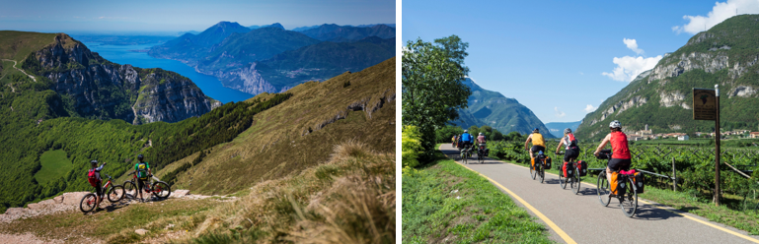

**The Via dell’Acqua was named the best Green Road in Italy in 2021 — over 140 km extending on a path that runs along the** **river banks and takes you to some of the most beautiful lakes in Trentino.**

**The GREEN ROAD DELL’ACQUA**

**Best Italian Green Road,** which begins in Bolzo and ends at Trento, have combined the nicest cycling and walking paths along Adige River, the Sarca, Lake Garda, Lake Toblino and other gems in the area, plus cities and villages. It is 143 km long, with 138 km dedicated to bicycles and pedestrians and 4 km are low-speed roads.

Starting from Cadino, and cycling at a convenient pace for about 25 km, you will reach the new gateway to the city of Trento. Next, you will leave the capital following the Adige River embankment and arrive at the gates of Rovereto. Continuing at Mori, the Valle dell’Adige cycle towards Verona and the Via dell’Acqua which diverges west towards Lake Garda, then head towards Passo San Giovanni to reach Nago and Torbole sul Garda. The cycle path then winds through an area of rare beauty where lakes are the main feature.

Continue cycling and you will appear at the Marocche Nature Reserve where you will feel as if you are on the moon because of the gigantic rocks. Few more kilometres and you will reach the town of Sarche, where the Parco Fluviale della Sarca begins. Moving towards Trento, soak in the Mediterranean beauty despite being surrounded by mountains, oaks, and olive trees. Towards the end of Via dell’Acqua, cycle up to Monte Bondone to see a panoramic view of Trento city.

**THE BRENTA CYCLE PATH: BIKE & TRAIN**

The Valsugana has been an important transportation route since ancient times, used by the military and then by merchants going beyond the Alps as well as pilgrims travelling to Jerusalem. Today, the traces of these passages can be detected along the cycling and walking path going from Lake Caldonazzo to Bassano del Grappa.

Continue cycling from San Cristoforo to Pianello Vallòn, then to Bassano del Grappa in Venice soaking in the picturesque views for 80 total kilometres. Alternatively when you leave San Cristoforo, you can ride along the Caldonazzo riverfront to Calceranica. Then the path goes through apple orchards and farmlands, arriving at the banks of the Brenta, in sight of Levico Terme.

The park at Levico Terme, full of ancient plants and exotic species, is on the list of Great Italian Gardens. Other short detours take you to the gates of the various castles: Castel Pergine, the Corte Trapp at Caldonazzo, Castel Telvana at Borgo Valsugana, Castel Ivano.

At Borgo Valsugana, you will cross the historic centre in The Trincerone di Grigno. After passing the bicigrill at Tezze, continue towards Martincelli to end up at Pianello-Vallòn, which is now the province’s border but used to mark the border of the Austro-Hungarian Empire.

There is also an option to take a **train** from Bassano to Trento, which runs Trento - Borgo Vlasugana - Bassano del Grappa route and can transport up to 6 bicycles.

**WINERIES AND VINEYARDS CYCLING TOUR**

**Wine Tour 50** starts at Piana Rotaliana and includes all 6 villages in the area, with detours to the north towards Salorno (Alto Adige) and to the east towards Giovo (Valle di Cembra). The route has two rings: one to the north, all flat, and the one to the south, with hills and different altitudes, however more scenic. This tour leads through incredibly beautiful vineyards, passing numerous wineries (from small family businesses to wine cooperatives) and architectural gems to be discovered one by one.

This route is directly accessible from the Valle dell'Adige bike path but can also be reached by train. The Trento railway station is a few kilometres away, and the regional trains stop in Mezzocorona as well as Lavis, while all the villages in the area are connected by the local Trento Malè railway on which bikes are permitted by reservation.

For more information visit: <https://girodelvino50.it/>