**An ideal weekend getaway for everyone**

**SPRING AT THE LAKE**

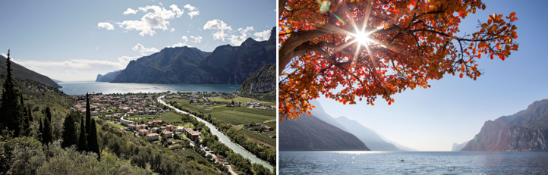

**Enjoy a relaxing time at lakeside beaches while soaking the sunshine or walking and pedalling along the lakefront as spring comes**

Warmer and longer days filled with sunshine and the smell of blossoming flowers - this is how Trentino looks in springtime. The nature surrounding **Lake Garda** awakens all senses and emotions with vibrant colours seen of fresh blossoming flowers.

Enjoy outdoor activities such as walking or cycling among the olive trees and the holm oak groves, admiring the view of the big lake crossed bye thousands of coloured sails, as well as strolls along the lakefront between Torbole and Riva that can offer truly special emotions and vistas. Take an easy trail from Pregasina to the scenic viewpoint overlooking the lake at **Punta Larici**. Discover Monte Brione path, a protected area between Torbole and Riva del Garda, which is home to 20 different species of orchid and three Austro-Hungarian forts from WWI.

Discover **Lago di Ledro**, and its hidden beaches, by canoeing, which would also be an exciting adventure for the little ones or take a bike ride along the Molina and Pieve path, continuing until the end of the valley at Passo d’Ampola, at the biotope full of water lilies or in the green Val di Concei.

**Lago di Tenno** is a picturesque location and an ideal picnic spot. The turquoise water is also home to a special biotope on a small island, where a second one can be seen when the water level is low. Just minutes from the lake lies the Medieval village of Canale di Tenno, is in the list of Italy’s Most Beautiful Villages.

**Lago di Molveno** lies at the base of the Brenta Dolomites, announced as one of the most beautiful lakes in Italy by the Italian Touring Club. Its waters reflect the still snowy peaks of the mountains, and it is the perfect place for families. You can walk or mountain bike around the entire lake to admire it from different sides as well as stopping for a break at the gourmet restaurant Baita Fortini di Napoleone. Fishing enthusiasts can travel to a nearby natural oasis **Lago di Nembia** as it is an ideal spot for fishing. Also visit Parco Segantini beach on the shores of Lake Levico, where you can take the Fisherman’s Path (Sentiero dei Pescatori) — a journey around the lake that almost becomes a Nordic fjord.

On the Altopiano di Pinè plateau, **Lake Serraia and Lake Piazze** are joined by a flat and pleasant footpath route great for families and cycling. At nearby Val di Cembra, **Lago** **Santo** is located. You can get there from Cembra, walking through vineyards and wood before arriving at this glacial lake.

**Lago di Calaita** lies in the highland Vanoi valley, beside Valle di Primiero, and offers a spectacular view of the Pale di San Martino. You can easily get there by car, going the road that goes up to the Gobbera pass. Surrounded by dense forests, the lake can be reached in about 2 and a half hours by feet.

Trento, February 2022