A JOURNEY THROUGH THE MOST SPECTACULAR ALPINE BLOOMS

Globeflowers in Baldo, Peonies in Ledro, the Apple Blossoms in Val di Non

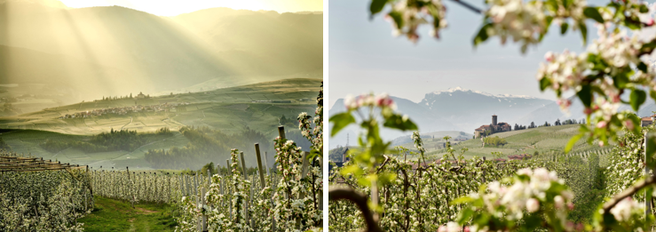

From the end of April to June, the northern Italian region of Trentino is in full bloom.

Between Vallagarina and Lake Garda, the area of Parco Naturale Locale del Monte Baldo has been famous among botanists from all over Europe since the Middle Ages and is known for its extraordinary biodiversity and richness of preglacial endemic species. Back in the sixteenth-century, Doctor Giovanni Battista Olivi defined the Monte Baldo Mountain range as the ‘Hortus Italiae’ (“Garden of Italy”) due to its immense botanical diversity.

Rare and distinctive plant species that grow in the region are called ‘baldensis’ to acknowledge their uniqueness. Lilies, gentians, orchids, globeflowers and silvery cranesbill burst into action between May and June, decorating the high meadows of Trentino with vibrant colours. To see these blooms, visitors can walk along the trails that make up the Malghe Baldo Flower Trekking Path designed to teach people about the biodiversity of the surrounding nature through sustainable tourism.

The most spectacular blooms can be seen by walking from the Graziani Mountain Hut towards Malga Campo, Bocca Paltrane to reach the Malga Campei Mountain Hut in Val Paròl where great expanses of globeflowers can be seen. As soon as the last snow melts, carpets of snowdrops surround the path from Polsa di Brentonico towards Malga Susine, Bocca d'Ardole and the WWI sites of nearby Corno della Paura. The trail, that climbs from Mori in Vallagarina to Brentonico, winds its way through broad leaf woods and then passes through the blossoming meadows around Brentonico and Dos Robiòn, a vantage point to see the entire plateau.

For more information: www.parcomontebaldo.tn.it

Monte Casale

Monte Casale has the best views in the Valle delle Terme di Comano. From the top of the peak, high meadows overlook the southern slope of the Italian Alps in Brenta. Nature springs to life in May and the blooming flowers transform the landscapes into a colourful fresco where the hues and the delicate fragrances of dozens and dozens of floral species come together. The extensive green meadow at the summit is sprinkled with crocuses, mountain tulips, orchids, peonies, gentians, lilies, Alpenrose, yellow archangel, as well as woodruff, lingonberry, mountain arnica, wild heather and wild spinach.

The ascent to Monte Casale is via an easy, leisurely route and is suitable for families. In order to go up to the parking lot at “Le Quadre” visitors must purchase the daily permit at the Panorama Hotel, the cost is per vehicle and is valid for the whole day. The money raised is used for the maintenance of the road itself. From the car park, visitors will continue uphill along the dirt road, pass the sign indicating Le Quadre (1479m) and continue straight on until the summit meadows of Monte Casale.

Dive into a sea of flowers

The spring transition is immediate in Valle di Non, known as the valley of apples. In just a few days the landscape dramatically changes from a lush green to a sea of pure white and pale pink blossoms. The apple trees bloom at the end of April, and it is the perfect time to discover this valley that is dotted with small and historic villages. Most can be reached by numerous hiking and cycling trails, passing through expanses of blooming apple orchards.

There is a trail close to the main town of Cles which leads through the beautiful blooms. Leaving from Piazza Fiera, walkers can meander past quaint houses and then through the orchards and woods, until the majestic Castel Cles is reached on an isolated hill surrounded by orchards, above Lake Santa Giustina. The route continues slightly uphill along the Nogare path to reach the hamlet of Maiano and then onto the ancient district of Pez where the ancient church of San Vigilio can be seen. Visitors will then return to the centre of Cles via Romana, stopping for a visit at the Palazzo Assessorile which is abundant with richly frescoed rooms.

Val di Non and Val di Sole’s ‘Road of Apples and Flavours’ includes a programme of events and initiatives designed for flower and nature lovers. “Aprile dolce fiorire” (Sweet April blossoms) has a full calendar of events from 8 April to 1 May that includes themed picnics with recipes based on flowers and herbs, tours to admire the blossoms up close, guided excursions to unique places such as the Sanctuary of San Romedio which is among the most sacred monuments in Europe, visits to wineries and distilleries and wine trekking.

More information: www.apriledolcefiorire.com

Passo Lavazè

Passo Lavazè in Val di Fiemme is a great place to admire wild and fragrant orchids such as Nigritella Rubra and Nigritella Nigra that smell like vanilla and chocolate, as well as Edelweiss.

In June, the Alpenrose (Rhododendron hirsutum) blooms on Corno Bianco and is recognised by its hairy leaves, while on the Corno Nero the Alpenrose (Rhododendron ferrugineum) blooms with shiny and hairless leaves. Flower lovers can also find the oblong-leaved sundew (Drosera intermedia), which grows at 1,780 meters in the peatlands of the Lavazé Plateau. No more than eight inches tall, it appears to be covered in dew, however, its leaves are sprinkled with sticky and shiny drops, capturing the insects. These spots, can be explored during the excursion from Passo di Lavazè that reaches the scenic top of the Pala Santa. .

