Giovanni Tava and Mattia Cristoforetti
Egg hen farmers (Company: “Uova di Montagna”) – Val di Gresta

Which came first, the chicken or the egg? This philosophic paradox was probably the spark behind the idea to build together what Giovanni and Mattia like to call an “egg boutique”. For a long time, they studied together the eggs and all the possibilities enclosed in their shells, but in order to give the original idea a complete company image, they necessarily had to deal with the famous original paradox. And to produce a dream egg, the two thirty-year-olds - who until that time had shared only a passion for windsurfing - decided to dive into the so far unexplored (for them) world of chickens. They dedicated their efforts to “literature on chickens”, but also contacted experts and veterinarians. They studied the life and habits of chickens, and finally understood that the only way to obtain the best out of production is to start from the animal’s well-being. The egg can be the essence and main ingredient even of dishes made by starred chefs, and the customer may notice that, behind the flavour, there is an entire world worth knowing, on condition of analysing and tracing the entire process back to its origins. The level of quality reached by the eggs brooded in Val di Gresta by the company’s Leghorn chickens, based on respect for the land and attention to the life cycle of the animals (which live in truly comfortable and clean spaces), has been awarded with the presence of this precious ingredient in dishes that appear on the menus of many starred restaurants.

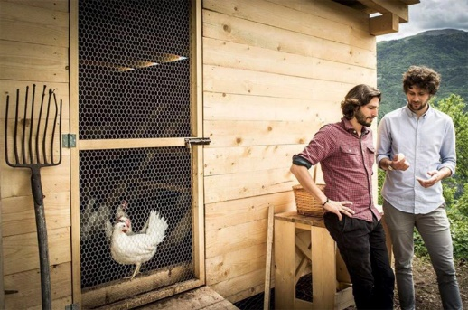

LINKS
https://www.uovadimontagna.info/

