Alessandro Gilmozzi
Chef (“El Molin” restaurant) / Cavalese, val di Fiemme

Alessandro Gilmozzi, born in 1965, has been challenging himself in the kitchen every day since 1990, when he opened the doors of his restaurant “El Molin” in Cavalese (TN), with the ambition of managing to express his own philosophy: in the picturesque Val di Fiemme, he presents mountain cuisine in an unusual manner. He likes to define it as “dolomitica”, because it is so closely linked with the local territory as to surpass time and become a new tradition. Over the years, constant research in the territory and collaboration with local producers has made this ancient mill an authentic cradle of creativity, and the patron’s kitchen, imbued with love and respect for the mountains, never ceases to amaze. Each new addition made to the menu is the fruit of painstaking, scientific research: from unusual raw materials, like bark or lichens, to the many mountain herbs that he studied and collects every day, either himself or in the company of a consulting botanical expert, all year round. Inventions which, blended with new cooking techniques (low temperature cooking, the creative use of smoke), accompany the guest into a world of tasty suggestions.

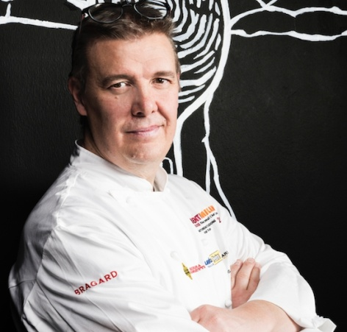

LINKS:
http://www.alessandrogilmozzi.it/EN/

